The Seminole Flyer www.seminolerc.com


A chartered member of the Academy of Model Aeronautics

AMA Charter #216, 1969-2008

“The Seminole Flyer” is a publication of the Seminole Radio Control Club of Tallahassee, Florida FEBRUARY 2008

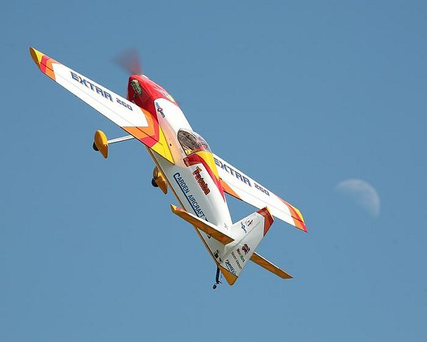
INDEX

Letter from the Editor
- Chief Pilot Report
- Club Calendar
- Chief Copilot Report
- Chief Treasurer Report
- Chief Scribe Report
- Pilot Briefing- Bill Rogers
- Review- E-Flite Blade 400
- Gas Engine Ignition Cutoff
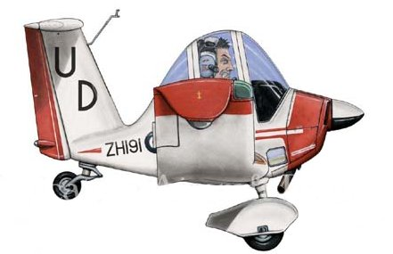

Letter from the Editor- Stephen Warmath
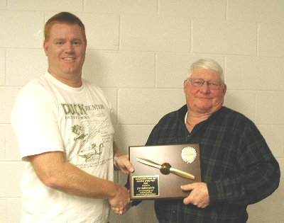

Congratulations to Joe Satterwhite (right) for being selected as Club Member of the Year 2007. Thanks for all your contributions to the Club Joe.

It looks like 2008 is shaping up to be a good year for Club activities. With discussions around a Fun- Fly Series, a Regional Float-Fly, and other events, we’ll have lots of opportunities to show our stuff. To help track these activities and help everyone with long range planning, beginning this month, I will include in the “Club Calendar” everything scheduled for the year. This schedule will be updated monthly adding new events as they are identified and for ones that are over, deleted from the list. The only non-club activity that will be listed in the Newsletter will be the Perry Show, since there are a number of members who attend.
(Hold on while I put my other hat on)
As Club Secretary, I will keep a Master Calendar at Club Meetings that has other non-Club related events of interest such as Sun-n-Fun, Joe Nall, or any other events identified. Of course, Regional Events for Florida, Alabama and Georgia will continue to be listed in the Newsletter.

Speaking of Perry, if you have never been to this event, it takes about 2:15 to drive up there and is well worth the trip. They have three buildings of everything from junk to treasures. If you are an RC junkie and need a major fix, this is the place to be Feb 29 & Mar 1. Hobbytown Tallahassee typically has a number of tables set up as well as the Club for those wanting to sell stuff. You can find more information about the event at:
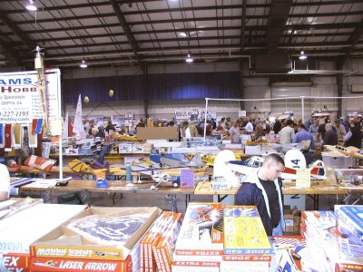

http://www.gamarc.com/georgia.html

This month we spotlight Bill Rogers in the Pilot Briefing. Gordie Meade shares his thoughts in his review of the new E-Flight Blade 400. Got that big gasser flying around on a full tank of gas with a throttle linkage failure? A little primer on the advanced issue of installation of an electronic ignition “kill” switch is offered.

Happy Building and Flying- Steve

Chief Pilot- Shannon Black
As we end the first month and begin the second month of the New Year, I realize just how lucky we are to live in Tallahassee. While most of the country has to deal with extreme cold and snow, those of us in Florida have been able to fly. During the past month, we have even been fortunate enough to have some new field improvements. John Hall has installed the second solar panel and battery system, and the charging stations should soon be complete. We have also had two new workstation tables installed, creating space for four pilots. If you have not yet seen them, please take a trip to the field. Hopefully, more tables will be added soon, creating a more organized environment for us all.

Speaking of organized, the Seminole RCC Fun Fly Series has taken off. When we first started talking of this event, I was hoping to round up 8 – 10 pilots to compete throughout the season. At my last count, we have about 22 pilots who have committed to this series. Hobby Town USA has the Sky Raiders in stock, and Frank will be placing another order soon. For those of you participating in these events, please try to come to the February meeting. We will be voting on several rules that will affect all of us participating. Remember, this is OUR event. If you don’t come to vote, please don’t complain about the rules.
We’re still soliciting ideas for improvements to the field and to our flying conditions. If there are changes that you would like to see, please bring them to my attention. Thanks again, and see ya at the field.

Shannon

Happy Flying- Shannon

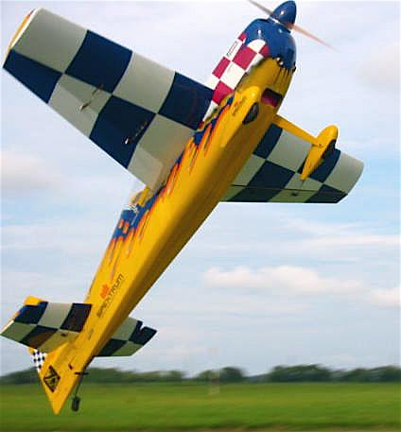
Club Calendar

February
- 7 - Club Meeting at Grace Lutheran Church. 7:30 pm.
- 23- Motorcycle Rodeo (Static Display) 9:00 – 3:00
- 24- SRCC Open House
- 29- Perry Show 1:00- 7:00 pm

March
- 1- Perry Show 8:00 am – 5:00 pm
- 7- Club Meeting at Grace Lutheran Church 7:30 pm
- 22- Regional Float-Fly Lake Surovec

April
- 3- Club Meeting at the Field 7:00 pm
- 5- Fun Fly Series Begins- #1 See web site “Events” section for details.

May
- 1- Club Meeting at the Field 7:00 pm
- 3- Fun Fly Series- #2
- 17/ 18- Airfest 2008
- 24- Flying for a Cure Event

June
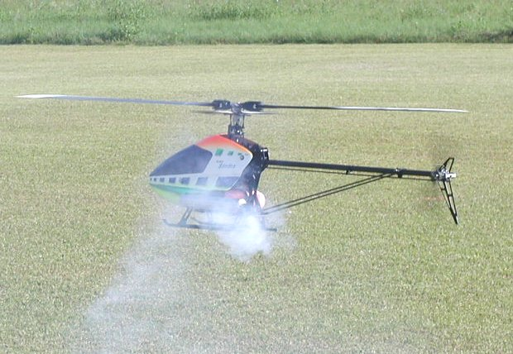
- 5- Club Meeting at the Field 7:00 pm
- 7- Fun Fly Series- #3

July
- 3- Club Meeting at the Field 7:00 pm
- 5- Fun Fly Series- #4

August
- 7- Club Meeting at the Field 7:00 pm
- 9- Fun Fly Series- #5

September
- 4- Club Meeting at the Field 7:00 pm
- 6- Fun Fly Series- #6

October
- 2- Club Meeting at Grace Lutheran Church. 7:30 pm.
- 4- Fun Fly Series- #7

November
- 6- Club Meeting at Grace Lutheran Church. 7:30 pm.
- 8- Fun Fly Series- #8

December
- 4- Club Meeting at Grace Lutheran Church. 7:30 pm.


“ Pump Faster”!!!!

Upcoming AMA Regional Events

SE IMAC Judging School
FL
2/03/08 - Jacksonville, FL (C) SE IMAC Judging School. Site: Club Field. Peter Jackson CD, 1908 Stillwind Court Jacksonville FL 32003 PH:954-205-5077 email: ppajack@aol.com. Sponsor: GATEWAY RC

MACH Wintercoupe
FL
2/09/08-2/10/08 - Pensacola, FL (AA) MACH Wintercoupe for 124, 140, 142, 153(JSO). Site: 8A. Bob Thoren CD, 1002 Bluff Dr Huntsville AL 35803 PH:256-880-8099 email: dthoren3@comcast.net. Commercial Rubber; 36 in span free wheel prop, classic towline glider. Sponsor: MODEL AIRPLANE CLUB OF HUNTSVILLE AL

TTOMA Monthly Indoor
GA
2/16/08 - Acworth, GA (A) TTOMA Monthly Indoor for Cat II 202, 203, 206, 207-208, 210, 213, 215, 217, 505, 507(JSO), 212, 218, 219, 220(J)(SO). Site: North Cobb High School. Gary Baughman CD, 470 Hardage Farm Dr Marietta GA 30064 PH:770-422-8489. Big 31' site with not drift. Motel and food nearby. Fly with National and World Record Holder Bill Gowen. Sponsor: THERMAL THUMBERS

19th Annual Winter Festival of Giants
FL
2/21/08/2/24/08 - Deland, FL (C) 19th Annual Winter Festival of Giants. Site: Deland Airport. Thomas Beckman CD, 104 Sycamore Lane Lake Helen FL 32744 PH:386-228-0700 email: tbeckman@cfl.rr.com. Landing fee $10 per day or advance registration of $20 for all four days by 2/14/08. Vendor welcome, there will be a limited amount of tent space bring your own tables. Camping on field from 2/20-24/08, no hookups. 80" mono 60" bi. Come have fun in the sun and fly till you drop. Sponsor: DELAND GOLDEN HAWKS

Wings Over Venice
FL
2/22/08-2/24/08 - Venice, FL (C-Restricted to IMAA) Wings Over Venice. Site: Memorial Field. Jack Butler CD, 211 Natures Way North Port FL 34287 PH:941-423-7037 email: jacknbutler@aol.com. Visit www.venicerc.pages.web.com. Exit US 75 East at exit 195 (Laurel Rd), Go 1 Block to Knights Trail Rd - turn Lft (north) follow RC Flying signs - obey all speed limits this is AMA/IMAA sanctioned event. Breakfast/lunch/rustic camping. Sponsor: RC FLYERS OF VENICE

AMPS Aerobatics Challenge
FL
2/23/08-2/24/08 - Miami, FL (AA) AMPS Aerobatics Challenge for 411, 412, 413, 414, 415(J)(S)(O). Site: Silver Field. Anthony Fandino CD, 159 SE 10th Ave Hialeah FL 33010 PH:305-887-9482 email: tony@ajfnet.com. Free style with awards, IMAL Aerobatics contest. Camping ok no hookups. Visit www.amps-rc.com. Sponsor: AEROMODLERS OF PERRINE

Florida Extreme 3D Fly In
FL
2/29/08-3/02/08 - Jacksonville, FL (C) Florida Extreme 3D Fly In. Site: Lannie Road Flying Field. Peter Jackson CD, 1908 Stillwind Court Orange Park FL 32003 PH:954-205-5077 email: ppajacks@aol.com. Camping ok, no hookups, concession stand, restroom facilities, Saturday evening BBQ with $25 landing fee, electric night flying. For further info contact Jeff Carte email: jccarte@bellsouth.net. Pilot raffle prizes. Visit www.gatewayrc.org. Sponsor: GATEWAY RC CLUB

Chief Copilot- Chris Bailey
As many of you have noticed while out flying this month, I have been playing the role of director and cameraman trying to capture the fun and excitement we all enjoy every time we put up a flight. After experimenting with different video editing software and rigorously reviewing each video captured for the perfect maneuver, I have finished what I propose we call, “If I Could Fly.”

“If I Could Fly” is the first part of a new promotional campaign to attract new members to the club by showing people not only where we fly, but also what it is like to spend a day out at the airfield. While the video does not display all facets of the hobby like float flying, scale planes, and events, it does show what it is like on a typical weekend at the airfield. The video is about five minutes in length and is split up into two parts: the first part features both electric and gas planes, and the second part features electric and nitro helicopters.

The plan at this point is to, as we discussed at the last meeting, burn the video as well as another video answering some FAQs about the club and hobby onto some CDs and place them at Hobby Town USA in a counter display. My hope is that people, whether they are purchasing a new plane or helicopter or just moving into town and looking for a place to fly, will pick up a copy as they leave the store and upon watching it consider joining the club. I also have plans to add the video to our website to attract interest online. Ultimately, I expect this will expand the presence of our club and promote interest and excitement into new pilots.

If you would like to see the video, come on out to the next club meeting. I will have my computer available so everyone can see it.

Chris

Chief Treasurer- Sam Varn
Editor’s Note: The Treasurer’s report is published for Members only. The public version of the Newsletter does not include account balances.

We've picked up three new or returning members this month. Please welcome George Julovich, David Miles, and Brett Johnson into the fold. Thanks guys and welcome to the Club.
Financially, we're stable although we continue to slide downward in our checking balance. With the upcoming events, maybe we'll get a little kick in the checkbook. We still have the small savings account we can move if needed. But with the newest round of interest rate cuts, I'm REAL glad we're locked in at 5.25% with our CD...at least until July or so. We've already earned over $1000 in interest (though not reflected in our numbers just yet). No telling where we'll be when it comes up for renewal but we'll worry about that when we get there.
In January, we paid AMA for the sanction and ad for the upcoming 2nd Annual Walter Dobson Fly-In, Chris Farrell for the new gate lock, Awards4U for the Member Of the Year plaque, a gavel for Shannon, and John Hall for the solar panel stuff. All that came to right at $670.50 but we got $90 in new dues and of course our checking account earned us $2.93 in interest! That being said, here's all our numbers:
Cash: $0.00 Checking (Premier): $0.00 Checking (Capital City): $0.00
CD: $0.00 Savings: $0.00
Total Funds: $0.00 That's all folks! Sam

Chief Scribe- Steve Warmath
Visitor/ New member Introductions- New Member Joe Cortese
Guest, and past Officer of the Club, Bob Dee
The Treasurer’s Report- Sam read off the current account amounts. Sam noted there had not been much activity for the month. Frank was given a check for the “Flying for a Cure” event to be sent to AMA. He reminded everyone that those who had not renewed his or her AMA or Club dues was on the “No Fly” list. He said that he receives a Banking Summary Sheet every year and that we had an approximately $500.00 negative cash flow for the year, but overall we broke even by $0.72. A motion was made to accept the report, seconded and passed.

Old Business-
- Shannon made a motion to accept the December meeting minutes, seconded and passed.
- Joe Satterwhite noted the lawnmower had the engine change thanks to Jay Luedecke. The hour meter read 211.8 hrs when changed. It now reads 212.7 hrs (about 1 hr. on the new engine) and would be noted with a tag on the engine indicating the time when the new engine was installed.

New Business-
- Theo Titus asked that the subject line of the e-mails sending the monthly Newsletter be more specific in an effort to not be filtered by spam prevention programs. Steve said he would include SRCC in the subject line when he sends them to Shannon for distribution. Jeff Owens added that anyone who has trouble or can’t receive the e-mail, the Newsletter is posted on the web site.
- Thanks to Chris Ferrell for getting a new combination lock for the gate. General consensus of members was to keep a combination lock for now.
- John Hall announced he had procured the new Solar panel, charger and battery and asked for help installing the equipment. He wanted any ideas for building a better charging box. There will be one extra charging box on the inside of the pavilion. He said he got a better, deep cycle battery. He also noted we need to build another battery box.
- Chris suggested that a work party be organized to do some maintenance around the field and work on the new charging system. He said an announcement would be made on the date.
- Jeff Owens talked about the pattern association and was looking for some dates for consideration for a sanctioned contest and the need to start outlining activities for the year. Two were identified in the immediate future. They were the motorcycle rodeo (static display) February 24th and the Perry show Feb 29/ Mar 1.
- Shannon mentioned the Democrat (Newspaper) was interested in doing an article about the Club. He had no specifics but wanted the members to know that it might be the reporters just show up at the field and start asking questions. If so, and you are present, please cooperate and be helpful if asked.
- Chris Bailey wanted to throw out ideas on how the Club could promote itself. With some discussion, the following ideas were mentioned:
- Develop a packet of information about the Club that could be handed out and left at the field for people to take with them. Some sort of box may be needed to put them in.
- Produce a short video about the Club and it’s activities. Maybe give away CD’s and post the video on the web site or link to a You-Tube file.
- Update pictures on the web site reflecting current events, etc.
- Provide on the website Google Earth links with field photos.
- Jeff Owens said that back in the 80’s, the Club had a series of Fun-Fly’s for members and at the end of the year various trophies were given out. He felt that that might be an idea we should re-visit as a way of promoting the Club from within.
- Safety Officer Appointment- Gordie Meade agreed to refill the position in the Club.
- Field Marshall- Joe Satterwhite agreed to accept the appointment.
- Mike Atkinson suggested that the Club have a long rang schedule of event plans to have more opportunities to get Club members together. Meetings at the Field were a good thing and we should continue to do this.
- Fred Schmidt announced that a Killearn Lakes Association was planning a Spring fishing tournament and thought it would be a good thing for a Float-Fly. Time and date were unknown. He would give the Club more information when known.
- Joe Satterwhite and Frank Bastos have keys to the gate and cabin at Francis Surovec’s property (Lake Surovec) for use in impromptu Float Fly’s.
- Club Field Work Day would include some things that needed to be done.
- Set up and install new charger system.
- Work on tables, etc.

Theo suggested e-mails be sent to the general membership for date. Shannon said he would pick a date and request volunteers.

- Jeff Owens wanted everyone to be thinking about Fun-Fly event ideas such as levels of achievement challenges, etc. They would be designed to improve level of proficiency for members. It was mentioned that events would be designed in such a way as to not give anyone an aircraft or equipment advantage. Maybe things like a slow flight pylon race, team egg-drop event or other fun type stuff.
- Chris Bailey volunteered to be one of the Fight instructors. His contact information will be added to the info page of the Newsletter. Mike noted that for $5.00, one can be certified through the AMA but it was only a temporary insurance provision that expired in 30 days after issuance. No one in the Club was currently certified by the AMA.
- Sam Varn asked for members with any outstanding receipts get them to him for payment.
- Mike Atkinson asked that Club events be listed before “Regional” Events in the Newsletter. Steve said they are we have any to report. Steve said that he would, starting with the next Newsletter, list all events for the year as they become known and remove them when over. This will give everyone a snapshot of what is planned to date for the rest of the year and will be updated every month in the Newsletter.
- Shannon wanted to outline what events we know of and discuss events in the immediate future.
- February 23^{trd} Motorcycle Rodeo (Club Models static display) 9:00 am – 3:00 pm
- February 24th- Open House (for Rodeo interested people)
- April Meeting to be at the Field.
- First Club Fun Fly on Saturday after March Club meeting (Later rescinded due to too many events clustered together, start in April)
- March 22nd- First Regional AMA sanctioned Float Fly- Lake Surovec.

- Question was raised about what we had in the way of Club caps, shirts, pins, etc. Mike said we had a few things left but we needed to look at this and decide what we needed. Discussion was deferred.
Announcements-
- Gordie Meade announced that Futaba is now shipping 14 channel (Spektrum) radios.
- Shannon thanked Frank from HobbyTown for letting him review the “Diablo”.
- Shannon announced and presented the 2007 Club Member of the Year award to Joe Satterwhite.
- Steve announced the meeting needed to end because he was running out of paper to write on. :0)

With no additional business, the meeting was adjourned at 8:40 pm.

Pilot Briefing- Bill Rogers
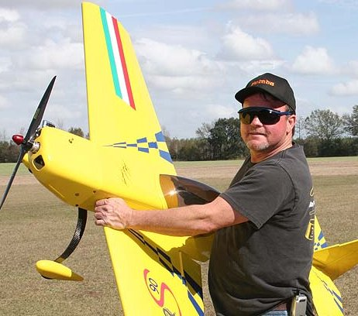

Where are you from? I was born in Tampa, Florida. I moved to Georgia for several years then moved back to Florida.
What do you do for a living? I’m currently an electrician employed at FSU. I have had this position now for 11 years.
How did you get started in radio control? Around the age of 11, my dad taught me to fly u-control airplanes. As I recall, it was a P-51 Mustang and during the third flight, I attempted a loop. Well, you know the rest. I splattered it on the deck. My dad introduced me to RC around 1996. I joined SRCC around 1998. It was a good opportunity to meet new people and learn more about the hobby.

Is there anyone in particular who has influenced your participation in the hobby? I want to say thanks to everyone who helped me, especially Jay, from the early days till present. Whether it is a plane or a heli, he has been very helpful. It’s a fun hobby and never a dull moment.

What models do you have or would like to have? What are your favorites and why? My favorite plane, may be a 40% Extra 260 or Edge 40.

E-Flite Blade 400 3D Review By Gordie Meade
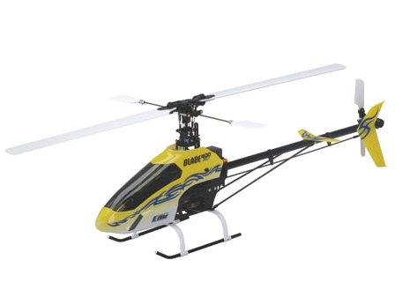
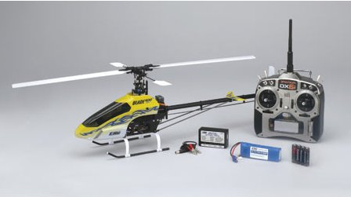

Frank, at Hobby Town, asked me to test the new E-Flite Blade 400 3D RTF helicopter.

Key Features (Per Manufacturer)
- Completely assembled and tested at the factory
- Capable of sport flying and 3D aerobatics right out of the box
- Includes Spektrum’s DX6i 2.4GHz DSM2 6-Channel computer programmable transmitter and factory-installed AR6100e Microlite receiver
- DS75 Digital Sub-Micro servos and G110 Micro Heading Lock gyro offer precise and powerful control
- 420H brushless motor, 25-amp brushless ESC and 3S 11.1V 1800mAh 20C Li-Po battery deliver incredible power and performance
- CCPM control with push-pull elevator and direct-to-swash aileron/pitch linkages
- Stainless steel flybar, main shaft and tail shaft

Specs (Per Manufacturer)
- Type: RTF Electric 3D Mini Heli
- Main Rotor Diameter: 28.2 in (718mm)
- Tail Rotor Diameter: 5.3 in (135mm)
- Gross Weight: RTF with Li-Po battery, 23.5 oz (665 g)
- Length: 25.6 in (650mm)
- Motor Size: 420H brushless outrunner, 3800kV
- Kit/ARF/RTF: RTF
- Control System: Spektrum DX6i 2.4GHz DSM2 computer programmable transmitter (included), Spektrum AR6100e Microlite receiver (installed), DS75 Digital Sub-Micro Servos (4 installed), 120 degree CCPM
- Rotor Blade Length: 12.8 in (325mm)

The model comes in a large case packed in pocket Styrofoam. It is completely assembled and includes all supplies necessary to put the model in the air.
The included radio is the Spektrum DX-6i 2.4 GHZ transmitter with and AR6100 receiver, four E-Flite S75 micro servos, an E-Flite G-110 micro gyro, an E-Flite 25 amp electronic speed control (ESC), an 1800mah Lithium Polymer flight battery, an E-Flite LiPo balancer/charger, and various cords, Velcro, etc necessary to get it in the air. E-Flite says that each and every model is test flown at the factory and will fly right out of the box. Programming is similar to the DX-6 and DX-7 from Spektrum and many of the JR radios but is not exactly the same. Gyro gain is transmitter adjustable and has built in dual rates.
Without any other assembly, I took the model to the field and plugged the charger into our solar array and put the flight battery on charge. I installed the 4 AA size dry cell batteries in the transmitter while waiting and gave the model the once over. I was impressed that the model was well done with all the wiring neatly bundled and cable tied to the frames. The frames themselves are well designed and look to be very sturdy, with the main shaft supported in bearings in three places. The rotor head is a trailing edge design that is simple and should be pretty durable, less a crash with direct impact to the head.
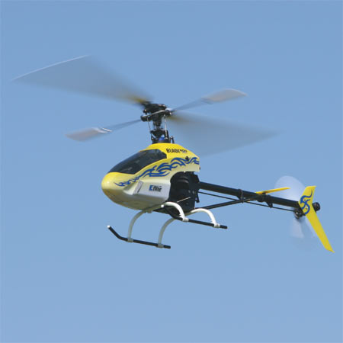
The battery charger is about as simple as it can be. You plug in the charger, (DC only), plug in the battery through the balance lead, and wait for all the lights to turn from green to red. The initial charge took about 45 minutes. I installed the battery in the model using the provided Velcro and went out to the flight line and fired the model up. It has slow start so the head spun up smoothly. I was unsure about how accurate the radio program was and how well the blades would track and how well in trim it was, but was pleasantly surprised when the rpm came up and the model climbed into a stable hover at a moderate head speed. The blades were already in track and the trim for hover was very close to neutral. The tail did wag just a little so I reduced the gyro gain about 5% in the transmitter and it basically just sat there in hover. Being a small model, the wind does affect the trim in hover but certainly no more than a T-Rex 450.
After hovering the model for a couple of minutes, I clicked the model into idle up for some aerobatics. The head speed climbed about 400 rpm and off we went. As set up from the factory, the model was very aerobatic, being capable of inverted maneuvers and cyclic rates were very good. The factory pitch curves worked pretty well so I just tooled around the sky doing rolls, loops, and flips. The model did each with ease so for $469 plus tax; you have a ready to fly, 3D capable little electric model, complete in the box.
We left the model bone stock the first day and I let John Hall, Jay, and visitor, Ray Hostetler, a well known California helicopter flyer (Ray’s Complete Helicopter Manual writer and producer of the DVD helicopter and radio set up series), try it. The general consensus was that for the price, the model was excellent. Power and control authority were very good. Tail rotor performance was adequate but a little “soft” in my opinion.
Pros:
- Complete in the box, ready to fly. Flight performance is very good. Parts are listed and available separately so any damaged parts can be replaced individually.
- All components of the radio and power system are discrete and could be removed from the model and used in other projects. None are built into the model, which is a BIG plus.
Cons:
- Tail rotor drive belt was too tight from the factory and consumed some of the available power.
- Provided charger works correctly for ONLY an 1800 mAh battery but current is NOT adjustable and while it will charge a larger battery, it will require more time. It should not be used to charger smaller capacity batteries.
- Transmitter uses replaceable batteries, AA dry cells, and from appearances will not accept a rechargeable transmitter pack.
- Tail rotor servo provided is a standard S75 servo, which works but gives only moderate tail performance. I would suggest getting a high quality fast digital micro-servo and think that would help tail performance quite a bit. The G110 gyro has a setting to accept a digital servo so someone thought ahead about this.
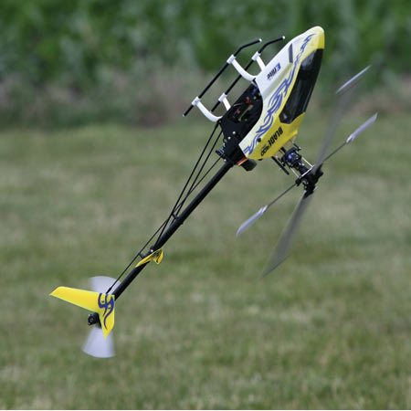
I bet there will be a gazillion of these models sold as they are just what the market demands, a good basic design, with good quality electronic products, complete in one box, for a moderate price. The model could benefit from some higher quality fiberglass or carbon fiber blades and a second and even third flight battery would be useful. I would bet we will see lots of “BLING”, upgraded beautifully anodized metal parts for this model but, to be honest, they aren’t needed. The only upgrade part I would like to see would be a metal head block, not for performance but only for durability.
In a nutshell, it works just like the box says.

Gas Engine Ignition Cutoff Devices
A HOW-TO ARTICLE- Author Unknown
There are several ignition cutoff systems on the market today. These cutoff devices are valuable since they provide both safety and convenience for gas-powered aircraft. For this how-to article I used an ignition cutoff device provided by Smart-Fly to show how they are installed, how to operate them and the benefits of such a device.
The extra safety that electronic cutoff devices provide are as follows:
- If the transmitter is OFF but the ignition is switched ON the cutoff device will prevent the engine from starting by accident.
- Safety while in the air - Should the receiver lose power from a dead battery, bad switch or broken wire the plane would normally go to the last throttle position. With this device it will kill the motor in such an event.
- If the throttle servo or linkage fails you can kill the motor to bring the aircraft down instead of flying around until the tank is empty which could be hazardous in a large, powerful aerobatic plane
This particular cutoff device consists of two modules that are connected by a fiber optic cable. The fiber optic cable ensures that there is no electrical connection between your ignition and the radio system which could cause interference.
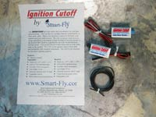 | 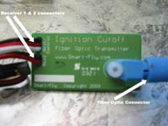 | 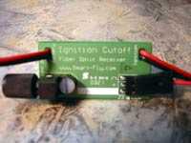
Modules, Fiber Optic Cable, Instruction Leaflet | Transmitter Module  Close-up | Receiver Module  Close-up
This particular unit has an added benefit. It actually recognizes and works with dual receiver systems that are quite common to large gas powered aircraft today. If your primary receiver loses power, the 2nd receiver can still control the cutoff so you don't lose power. This way you aren't forced to land dead stick if one RX is still working.
On the technical side the modules work like this: The transmitter module sends light via the fiber optic cable to the receiving unit. When the transmitter is sending the signal the receiver turns on its electronic power switch allowing the ignition unit to receive power from the ignition battery. When the transmitter is off, it turns the power off to the ignition.
INSTALLATION OF THE SMART-FLY IGNITION CUTOFF DEVICE
Installing the device is a very simple and fast process. For this article I decided to install it into my Wildhare 35% Giles. The first step is to plug the transmitter module's deans connector into the auxiliary channel of your radio. This is the channel where you will switch the ignition on and off. The channel you select will vary depending on your particular radio and setup. It is best to put it on a switch that is easily accessible BUT not one that is likely to be accidentally switched thus causing a dead stick! The transmitter module is marked for receiver one and receiver two. If using only one receiver just tie up the 2nd lead with a twist tie to keep things neat and plug ONLY the receiver 1 lead into your RX
Next loosen up the ferrule (fiber optic connector) and insert the fiber cable into the hole. It should go in about 5/8" then tighten the ferrule. This will keep the fiber optic cable secure. Mount the unit using either Velcro or some foam as I did in this installation to protect from vibration.
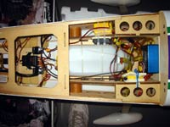
Modules, Fiber Optic Cable, Instruction Leaflet | Transmitter Module  Close-up | Receiver Module Close-up
Next the cutoff receiver module is installed. The receiver unit should be mounted near the ignition unit. It must go between the ignition on/off switch and the ignition module. Don't put it between the battery and the switch because the receiver module will always be on and drain your battery. The lead marked battery goes to the ignition switch side and the lead marked ignition goes to the ignition itself. Next, you must route the fiber optic cable from the transmitter module to the receiver module. Although the cable can be cut with a sharp knife to customize its length, I just coiled up the excess in case the system was ever used in another plane which required additional length. Once the cable is run you secure it to the fiber optic connector the same as was done with the transmitter. Last, mount the module with some foam or Velcro to protect from vibration.
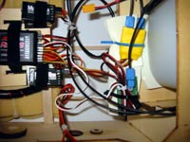 | 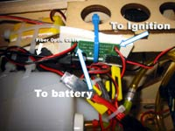
Transmitter Module Installed | Receiver Module Installed

The last thing to do on this installation is install the optional red LED onto the fuselage. For this I drilled a 1/4" hole per the instructions. I removed the deans connector from the LED assembly and slipped the wires through the hole. The housing just pushes in snug into the hole. You can see the completed installation below.
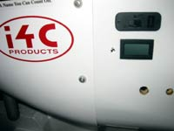 | 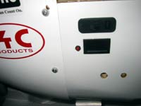
1/4" Hole Drilled for LED | LED installed!
To test the system turn your radio and ignition switches on. Flip the switch on your transmitter that you assigned and look at the transmitter module which will show a lit green LED when "hot" (see pic below). If you installed the optional LED as I did you will see the red LED light up as well. I've tested this in sunlight and you can see the LED fine. This is a great visual indicator so you know when the ignition is hot.
If you are using a single PCM receiver with this particular device you should set your transmitter failsafe to cut the engine. Since my Giles uses a single receiver I setup my JR 10X to kill the ignition in the event it goes into failsafe mode for any reason.
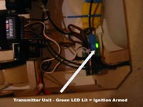 | 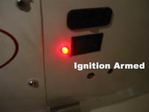
Transmitter Module Green LED | Receiver Module Red LED
That is all there is to it. The installation took me about 25 minutes total including taking all these pictures for the article. If your looking for some extra safety, peace of mind and a visual indicator to know when your ignition is armed consider installing a cutoff device in your gasoline powered aircraft. I know I'll be flying with a lot more peace of mind this season!
For information on the Smart-Fly cutoff device used in this article visit www.smart-fly.com

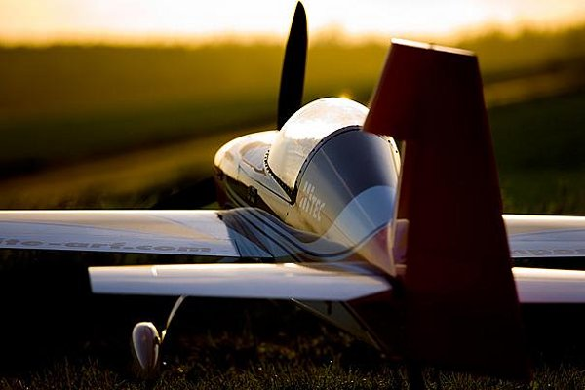

Seminole Radio Control Club
Tallahassee, FL

AMA Charter #216, 1969-2008

SRCC Officers

President – Shannon Black
Vice President – Chris Bailey
Secretary/ Newsletter Editor – Stephen Warmath
Treasurer - Sam Varn
Field Marshall – Joe Satterwhite
Field Safety Officer- Gordie Meade

Field Hours

12 Noon till Dark- These hours apply to all aircraft, gas and electric.

Training Notes

To schedule a training time contact Mike Atkinson.

Flight Instructors
Mike Atkinson- Primary/ Advanced Fight Instructor (Coordinator) 926-4692
Geoff Lawrence- Primary/ Advanced Fight Instructor 942-9807
Chris Bailey- Primary/ Advanced Flight Instructor 322-4047
John Hall- Primary/ Advanced Helicopter Flight Instructor 893-6457
Jay Leudecke- Primary/ Advanced Helicopter Flight Instructor 508-7135
Jeff Owens- Ground School/ Airworthiness Instructor (Fixed Wing) 894-2504
Frank Bastos- Hobby Town Flight Demonstrator 671-2030

Club Meeting Location and Time
October- March: The regular club meetings are held on the first Thursday of each month at 7:30 PM at the Grace Lutheran Church on Miccosukee Rd. Head out Miccosukee Rd., cross Capital Circle NE, and the entrance will be the first one on your right. Once you park, follow the sidewalk around the left side of the building and go down the hill. We meet in a room on the first level.
April- September: The regular club meetings are held on the first Thursday of each month at 7:00 PM at the Flying Field. The Club provides food and drinks.
Newsletter Submissions- Submissions are requested to be in M.S. Word format or via e-mail text. Photos should be in .jpg or .tif format. Vector art accepted in Corel, Illustrator and AUTOCAD format. We will, however, accept anything to make it easier for those who wish to contribute. Submissions are due no later than the 23rd of the month. Send your submissions to ssw@nettally.com or by phone, Steve Warmath at 509-0672.
Hard Copy Printing of the SRCC Newsletter provided by Apogee Signs & Graphics. 850-224-7446



