The Seminole Flyer www.seminolerc.com


A chartered member of the Academy of Model Aeronautics

AMA Charter #216, 1969-2008

“The Seminole Flyer” is a publication of the Seminole Radio Control Club of Tallahassee, Florida SEPTEMBER 2008

INDEX
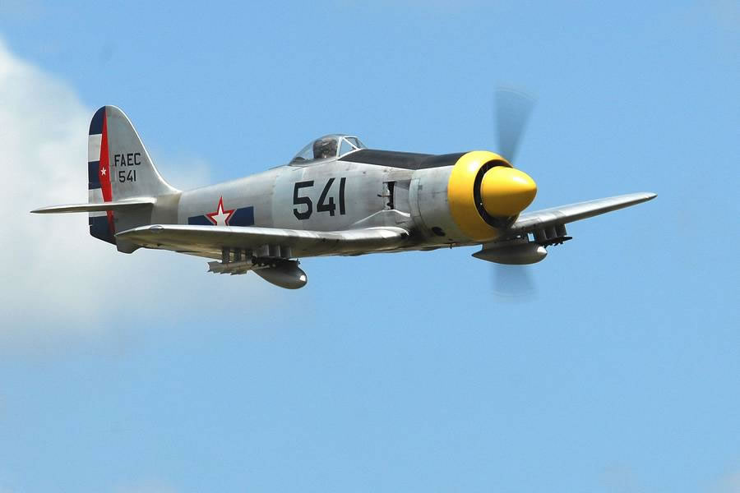

Letter from the Editor
- Club Calendar
- Chief Pilot Report
- Chief Copilot Report
- Chief Treasurer Report
- Chief Scribe Report
- “C” Rating of batteries
- Wing Loading
- Sneak Peek
- War Story


Letter from the Editor- Stephen Warmath

Ahhhhh…September. Fall is my favorite time of year. The weather will be cooling in the next few months, leaves will start to fall and football is getting underway. I hope everyone faired well during the recent deluge we received from tropical storm Fay. Nothing like making up a rainfall deficit in three days. There is actually water in Lake Jackson! Hopefully no one had any damage.
We start this month for the watt flyers, a quick explanation of a battery’s “C” Rating.
Also included are a couple of web links to some neat videos. The first, http://www.wservernews.com/4HA6HM/080811-RC-C-17 Is a 4 engine, 20’ ws, 260 lb C-17 Globemaster III., Awesome. The second, http://www.wservernews.com/4HA6HM/080825-VOLT Is a 2003 VTOL prototype, an electric powered model with 3-axis gyro stabilization. Weight: 5.5 lbs. Wing Span: 3.5 ft, built from balsa and mylar. Next up, Wing Loading. Will it float like a butterfly of fly like a rock? The chart outlines the general range of loading parameters for different types of aircraft. We get a Sneak Peek at Park Zone’s F4U Corsair RTF. Topping it off is a warm War Story sent in by Geoff Lawrence.

Happy Building and Flying- Steve :o)

Chief Pilot- Shannon Black

Well guys, we've made it through another hot summer month. We're on the downhill side of the heat once again. Unfortunately, we're still in the middle of the rainy hurricane season. Fay has definitely left her mark on our area and new storms may be on the horizon. Just think positive, and use those rainy days as a chance to finish that model that you might not normally have time for.

This month has been a slow one at the field. The Fun Fly Competition series was temporarily put on hold as summertime responsibilities left us with only a few pilots. After a months rest, lets hope that everyone comes back ready to fly.

Finally, let's all keep Brian Campbell's family in our thoughts and prayers. As most of us know, Brian, a longtime club member and master builder, recently passed away. His ashes have been spread at our field, which certainly demonstrates his commitment to our club. Brian will definitely be missed.

Until next month, I'll see ya at the field.

Shannon

Club Calendar

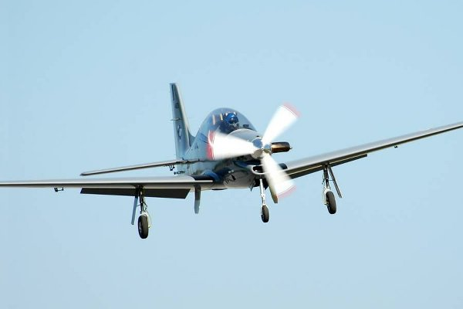

September
- 4- Club Meeting at the Field 7:00 pm

October
- 2- Club Meeting at Grace Lutheran Church. 7:30 pm.
- 11 Fall Fly-In

November
- 6- Club Meeting at Grace Lutheran Church. 7:30 pm.

December
- 4- Club Meeting at Grace Lutheran Church. 7:30 pm.
- 6- Warbird Fly-In

Chief Copilot- Mike Atkinson

Upcoming AMA Regional Events
3rd Annual BUSHWHACKED '08 1/2
FL
9/06/08-9/07/08 - West Palm Beach, FL (A) 3rd Annual BUSHWHACKED '08 ½ for 755(JSO). Site: Phil Wherry Field. Chris Handegard CD, 2774 New York Street West Palm Beach FL 33406 PH:561-832-1921 email: chandegard@peersonaudio.com. Visit www.rcbushpilots.com. Sat 8 rounds of Open B, 4 rounds SSC - Sun 8 rounds 2548 Scale Combat, 4 rounds SSC. Field open 8am, Start combat 10am, entry fee $20 first event, $10 each additional event, trophies 1st to 5th place. Visit www.rccombat.com to sign up online. Sponsor: RC BUSHPILOTS

Northwest Florida Modelers 3rd IMAC
FL
9/06/08-9/07/08 - Pensacola, FL (AA) Northwest Florida Modelers 3rd IMAC for 411, 412, 413, 414, 415(JSO). Site: Fritz Field. Ron Bullard CD, 2808 Sandy Ridge Rd Gulf Breeze FL 32563 PH:850-501-0358 email: ronbullard1401@aol.com. Sponsor: NORTHWEST FLORIDA MODELERS

Bud McMillan Memorial Bug Bird Fly In
FL
9/19/08-9/20/08 - Jacksonville, FL (C) Bud McMillan Memorial Big Bird Fly In. Site: Club Field. Ewell Howard CD, PO Box 892 Callanan FL 32011 PH:904-502-7674 email: bhoward32011@aol.com. Visit www.gatewayrc.org. Landing fee $20, $10 Sat both days includes Fri night BBQ for pilots, extra tickets available, Hot food, RV parking no hookups, vendors welcome, many prizes for pilots, 60" bipl, 80" mono, 140 jets. Sponsor: GATEWAY RC CLUB

Hush Up FF Gathering
FL
09/20/08-09/21/08 - Palm Bay, FL (A) Hush Up FF Gathering for Cat III 124, 142(J)(SO), 140(SO), 153(JSO). Site: Club Field. Ray Combs CD, 6747 Sugarbush Dr Orlando FL 32819 PH:407-351-2209 e-mail rcombsjr@cfl.rr.com . Come on down for some fun in the sun and see who is best at picking air. Bring a junior flying (under 15 yrs) and he/she could win an aviation stamp collectors plaque. Sponsor: FLORIDA MODELERS ASSN

Bud McMillan Memorial Bug Bird Fly In
FL
9/19/08-9/20/08 - Jacksonville, FL (C) Bud McMillan Memorial Big Bird Fly In. Site: Club Field. Ewell Howard CD, PO Box 892 Callanan FL 32011 PH:904-502-7674 email: bhoward32011@aol.com. Visit www.gatewayrc.org. Landing fee $20, $10 Sat both days includes Fri night BBQ for pilots, extra tickets available, Hot food, RV parking no hookups, vendors welcome, many prizes for pilots, 60" bipl, 80" mono, 140 jets. Sponsor: GATEWAY RC CLUB

Summer's End
FL
9/20/08 - Ocala, FL (C) Summer's End. Site: Club Field. Tom Thacker CD, 15702 SW 16th Ave Rd Ocala FL 34473 PH:404-625-9497 email: tthacker6@cfl.rr.com. Come fly at one of the best flying sites in the Southeast, $5 landing fee for the weekend, Flying 9am to 4pm each day, on site camping, no hookups, food and beverages provided by the OFMC Fly Girls, Giant Scale Rules apply 80" mono, 60" bipe or true ¼ scale. Visit www.ocalaflyingmodelclub.com. Sponsor: OCALA FLYING MODEL CLUB

32nd Annual OJ Stillman Memorial
FL
9/26/08-9/28/08 - Jacksonville, FL (AA) 32nd Annual OJ Stillman Memorial for 401, 402, 403, 404,406(JSO). Site: Lannie Rd Flying Site. Tony Stillman CD, 102 Cherrywood Ct Brunswick GA 31525 PH:912-242-2407 email: tony@radiosouthrc.com. Visit www.gatewayrc.org. No noise test, in F1A we will fly "P" on Saturday and "F"on Sunday. Sponsor: GATEWAY RC

Chuck Yeager Fly In
FL
09/27/08 - Dunnellon, FL (C) Chuck Yeager Fly In. Site: Rainbow Air Park. Richard Lafontaine CD, 4283 N Pink Poppy Dr Beverly Hills FL 34465 PH:352-746-7425 e-mail: lafontaine5@aol.com . Over night parking, no hook ups, eat at the Rainbow Café. Military aircraft of all sizes and vintage welcome, landing fee $10. Sponsor: TRI COUNTY

Chief Treasurer- Sam Varn
Editor’s Note: The Treasurer’s report is published for Members only. The public version of the Newsletter does not include account balances.

Petty Cash: $0.00 Premier Checking: $0.00 Capital City Checking: $0.00
Capital City Savings: $0.00 SunTrust CD: $0.00
Total Funds: $0.00

Sam

Chief Scribe- Steve Warmath

The August meeting was called to order at 7:05 pm Thursday August 7, 2008.
A request for a motion to accept the Secretary’s July meeting minutes was made, seconded and passed.

Visitors/ New Members- Keith Campbell, a Tallahassee Police Dept. Investigator is a new member and flies a PTS P-51.

Treasurer’s Report- Mike Atkinson read off the Treasurer’s numbers from the newsletter. A request for a motion to accept the Treasurer’s report was made, seconded and passed.

Old Business-
- The Fun Fly for July was cancelled due to 4th of July. Next series was also cancelled due to lack of member participation.
- Bob Burke said he was doing well after tangling with his plane. He thanked those who helped him during his injury at the field.
- Grading of the roadway is outstanding old business. Mike said he would make a call to the County to have this done.
- Generator- It was noted that a generator was priced through Harbor Freight for $500.00 plus $100.00 for 3 year warrantee. Theo Proctor advised that buying cheap off-brand equipment may make it difficult to get service or parts. Ken said that there is on-going dialog with the County to bring power to the site. The purchase of a new generator was put on hold until a final determination was made on power to the site.

New Business-
- Ken added that the County Commission agreed to maybe run power to the site later as they are short on money. He was still going to meet with Talquin Electric to look at re-routing to get the number down. He was waiting for cost information from Talquin so the Club can decide if they want to go forward with the purchase of a generator.
- Bob Burke wanted everyone to know he had a bad experience with a company called BCMA Engines in Laramie, Wyoming. They were not responsive, did not return calls and were late with deliveries.
- Shannon announced Brian Campbell had been diagnosed with lung cancer. He said the club should get something in the way of a card and gift basket to wish him well. Michael Hupp to coordinate.
- Congratulations to Jeff Owens for his recent string of first place finishes in the Senior Pattern series of competitions. Also noted was Gordie Mead’s 6th place finish at the Nationals and appointment as second alternate on the World Team. Way to go guys!
- Joe Satterwhite said he had received some complaints about field undergrowth. The grass needed to be aerated and de-thatched. He said he would inquire about having it done by an outside service. and report back to the members.
- Shannon announced that lately Sundays had a good turn out and that they had been having lunches and invited everyone to come out.
- Mike reminded everyone that The Fall Fly-In was scheduled for October 11 and a Warbird Fly-in was scheduled for December 6.
- The Killearn Community picnic was on again this year in October but no firm date had been set.

With no additional business, the meeting was adjourned and flying resumed at 7:40 pm.

“C” Rating- What does it mean?

We hear it from the grizzled veteran pilot who’s been flying since he lived next door to Wilbur and Orville Wright. We get the same question from guys who have with so little experience with electricity they think that Watts is just a neighborhood in L.A.
So what does the “C” rating on a lipo mean? For starters, the ‘C” in “C Rating” stands for capacity. To break it down to its simplest terms, the “C” rating is the maximum safe continuous discharge rate of a pack. If you see 10C on your battery, it means it can be discharged at 10 times that pack’s capacity. “Capacity” refers to the milliamp-hour rating of the battery, which will be listed as a number followed by mAh (2000mAh, for example).
Here’s the easy way to find your battery’s discharge rate – just multiply the number from the “C” rating by the pack’s capacity. Keep in mind that 1000 milliamps equals one amp. Here’s an example, using an 11.1V – 2000mAh – 10C –
11.1 volt – 2000mAh -10C
2000 milliamps = 2 amps
2 Amps x 10 = 20 amps continuous discharge
This means that you can safely draw up to 20 amps continuously from that 11.1V – 2000mAh – 10C without doing damage to your battery. Our packs have all the discharge information printed right on the label. You can check out one of our labels right here. We hope this helps clarify the most misunderstood aspect of electric flight.

Wing Loading
Wing loading is the weight that a given area of the wing has to lift and is usually measured in ounces per square foot.
Generally, a light wing loading is best for beginners. The plane will perform better and be easier to control.
To determine the wing loading, divide the weight of the plane by the wingspan and multiply that by the wing chord divided by 144.
Wing Loading
Loading | Type
10 oz/sq.ft | Gliders
15 oz/sq.ft | Trainers
20 oz/sq.ft | Sport Planes
25 oz/sq.ft | Warbirds

SNEAK PEEK!
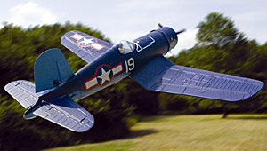
ParkZone F4U Corsair RTF
By Gerry Yarrish
There’s no other warbird like it! The F4U Corsair was developed from the original 1938 Vought V-166B into the Navy designation XF4U-1. Many tweaks were made along the way and its classic inverted gull-wing design was developed to do two things: it kept the landing gear as short as possible (for carrier operations) and it provided proper ground clearance for its 13.2-foot-diameter, 3-bladed propeller attached to its powerful 2000hp Pratt & Whitney R-2800-8, Double Wasp radial engine. Production of F4U-1s began in 1942 and the Corsair quickly earned the nickname “Ensign Eliminator” because of its demanding handling characteristics. Flown by experienced pilots, the Corsair was both loved and respected, especially in the South Pacific where the Japanese referred to it as the “Whistling Death.” If you’re not familiar with this amazing WW II warbird, do yourself a favor and search online for Major Gregory “Pappy” Boyington and the VMF-214 “Black Sheep Squadron.”
The Parkzone F4U Corsair is a true ready-to-fly airplane and it comes with everything you need. The radio gear, control linkages and power system all come installed. All you have to do is slide the horizontal stabilizer/elevator assembly into its slot, tape it into place and connect the elevator pushrod to the control horn. An 1800mAh 3-cell LiPo pack and a 12V balancer/charger are also included, but you’ll have the Corsair completely ready to go before the battery is fully charged. Assembly time is about 10 minutes!.
In the Air
STABILITY As far as warbirds go, the Corsair has always been noted for excellent stability. The same is true for this one and I found that high rate control provides great control response without being twitchy.
TRACKING On the ground and in the air, tracking is solid. The functional rudder is great for yaw control and you’ll appreciate it if you’ve flown other warbirds with aileron- and elevator-only control.
AEROBATICS Rolls are nice and gentle, as are the loops. There’s plenty of power on tap with a fully charged battery for good vertical climbs so things like Split-Ss or wingovers are a great way to change directions. Inverted flight requires a bit of forward stick to maintain straight and level flight.
GLIDE & STALL PERFORMANCE The Corsair is fairly light for its size so it has an attractive wing loading. Stalls are easy to recover from should you pull way back on the stick and pull the power off. During the slow flybys and high-banked turns, the model never felt like it was going to snap out or drop a wing.
Specifications
MODEL F4U Corsair
MANUFACTURER ParkZone
DISTRIBUTOR Horizon Hobby
TYPE WW II Warbird (ARF)
WINGSPAN- 44 in.
WING AREA- 395 sq. in.
WEIGHT 30 oz.
WING LOADING 10.94 oz./sq. ft.
LENGTH 36 in.
RADIO GEAR 4-channel (rudder, elevator, aileron, throttle)
PRICE $280
Catch the full review in the November 2008 issue of Backyard Flyer!

War Story
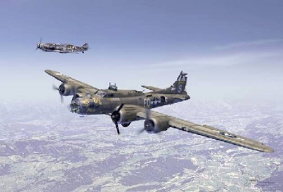
Look carefully at the B-17 and note how shot up it is - one engine dead, tail, horizontal stabilizer and nose shot up. It was ready to fall out of the sky. Then realize that there is a German ME-109 fighter flying next to it. Now read the story below. I think you’ll be surprised. Charlie Brown was a B-17 Flying Fortress pilot with the 379th Bomber Group at Kimbolton, England. His B-17 was called ‘Ye Old Pub’ and was in a terrible state, having been hit by flak and fighters. The compass was damaged and they were flying deeper over enemy territory instead of heading home to Kimbolton. After flying over an enemy airfield, a German pilot armed Franz Steigler was ordered to take off and shoot down the B-17. When he got near the B-17, he could not believe his eyes. In his words, he ‘had never seen a plane in such a bad state’. The tail and rear section was severely damaged, and the tail gunner wounded. The top gunner was all over the top of the fuselage. The nose was smashed and there were holes everywhere Despite having ammunition, Franz flew to the side of the B-17 and looked at Charlie Brown, the pilot. Brown was scared and struggling to control his damaged and bloodstained plane.
Aware that they had no idea where they were going, Franz waved at Charlie to turn 180 degrees. Franz escorted and guided the stricken plane to, and slightly over, the North Sea towards England. He then saluted Charlie Brown and turned away, back to Europe. When Franz landed he told the CO that the plane had been shot down over the sea, and never told the truth to anybody. Charlie Brown and the remains of his crew told all at their briefing, but were ordered never to talk about it. More than 40 years later, Charlie Brown wanted to find the Luftwaffe pilot who saved the crew. After years of research, Franz was found. He had never talked about the incident, not even at post-war reunions. They met in the USA at a 379th Bomber Group reunion, together with 25 people who are alive now - all because Franz never fire! d his guns that day.
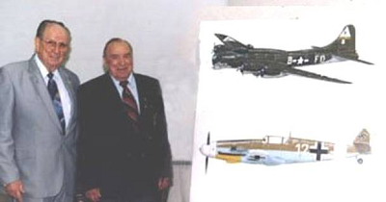

Seminole Radio Control Club
Tallahassee, FL

AMA Charter #216, 1969-2008

SRCC Officers

President – Shannon Black
Vice President – Mike Atkinson
Secretary/ Newsletter Editor – Stephen Warmath
Treasurer - Sam Varn
Field Marshall – Joe Satterwhite
Field Safety Officer- Gordie Meade

Field Hours

12 Noon till Dark- These hours apply to all aircraft, gas and electric.

Training Notes

To schedule a training time contact Mike Atkinson.

Flight Instructors
Mike Atkinson- Primary/ Advanced Fight Instructor (Coordinator) 926-4692
Geoff Lawrence- Primary/ Advanced Fight Instructor 942-9807
John Hall- Primary/ Advanced Helicopter Flight Instructor 893-6457
Jay Leudecke- Primary/ Advanced Helicopter Flight Instructor 508-7135
Jeff Owens- Ground School/ Airworthiness Instructor (Fixed Wing) 894-2504
Frank Bastos- Hobby Town Flight Demonstrator 671-2030

Club Meeting Location and Time
October- March: The regular club meetings are held on the first Thursday of each month at 7:30 PM at the Grace Lutheran Church on Miccosukee Rd. Head out Miccosukee Rd., cross Capital Circle NE, and the entrance will be the first one on your right. Once you park, follow the sidewalk around the left side of the building and go down the hill. We meet in a room on the first level.
April- September: The regular club meetings are held on the first Thursday of each month at 7:00 PM at the Flying Field. The Club offers food and drinks for a small charge.
Newsletter Submissions- Submissions are requested to be in M.S. Word format or via e-mail text. Photos should be in .jpg or .tif format. Vector art accepted in Corel, Illustrator and AUTOCAD format. We will, however, accept anything to make it easier for those who wish to contribute. Submissions are due no later than the 23rd of the month. Send your submissions to ssw@nettally.com or by phone, Steve Warmath at 509-0672.
Hard Copy Printing of the SRCC Newsletter provided by Apogee Signs & Graphics. 850-224-7446



